Pointers:  
Task001:

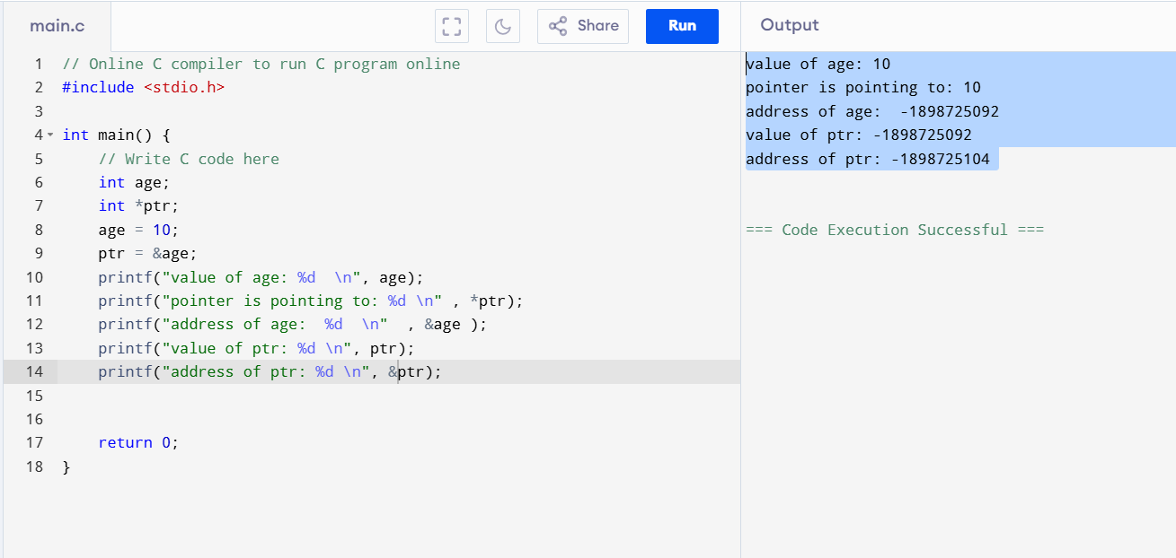

Task002:

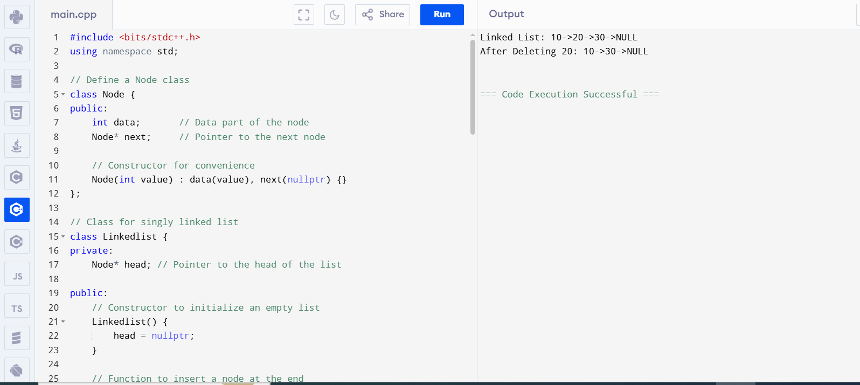

Task03:

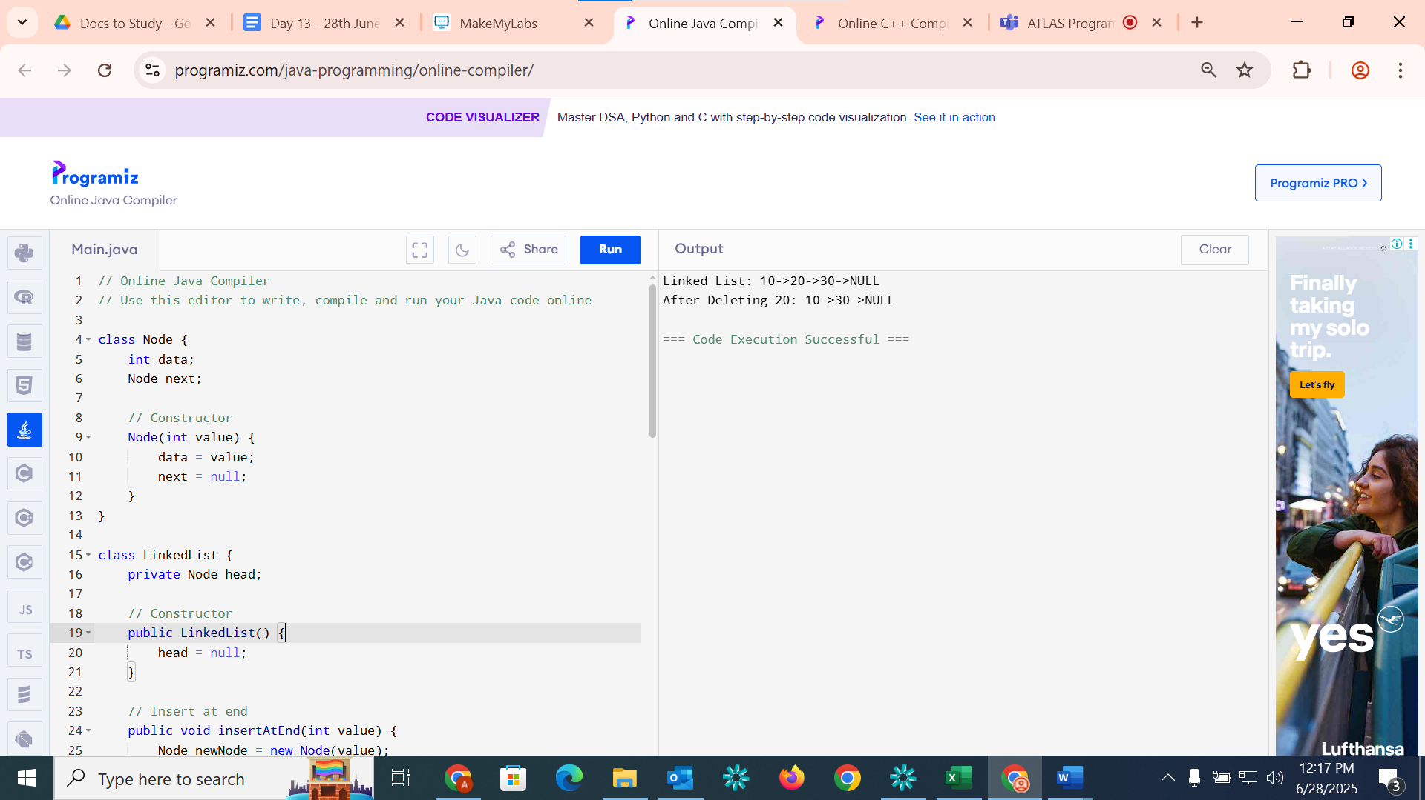

Task04:

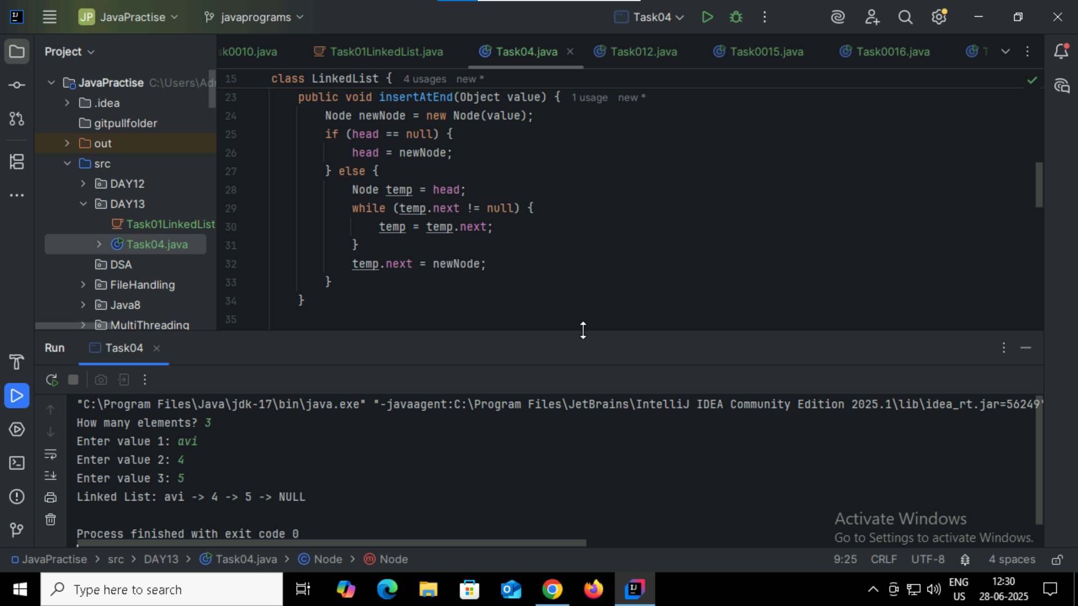

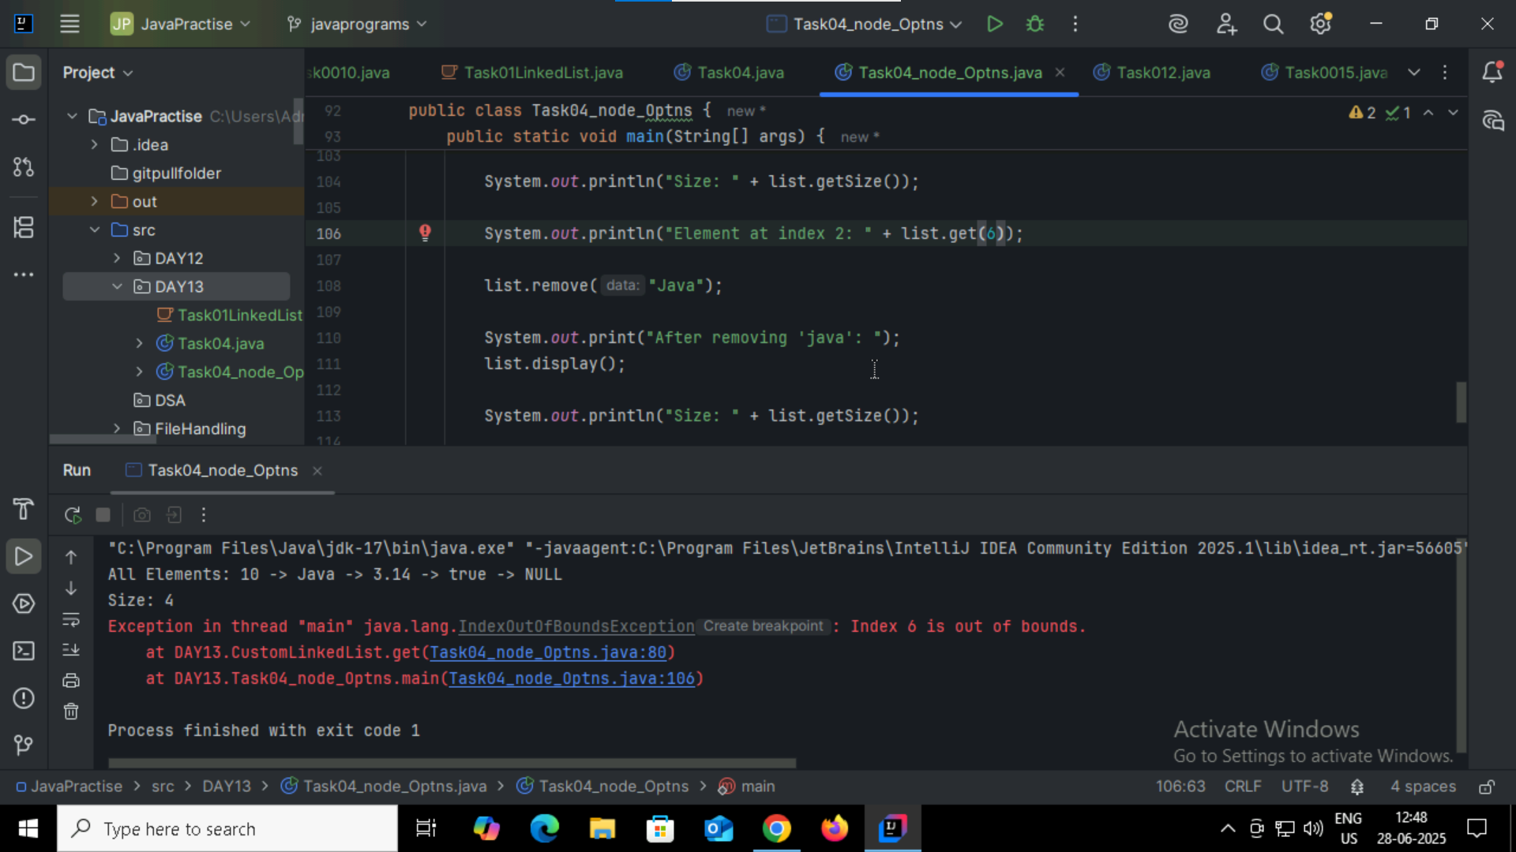

Task005:  
List down all the methods of Linked list

Add() addFirst() addLast() clone() size() indexOf()   
remove() removeFirst() removeLast() push() pop() isEmpty()   
Clear() get() getFirst() getLast() contains()

Task006:

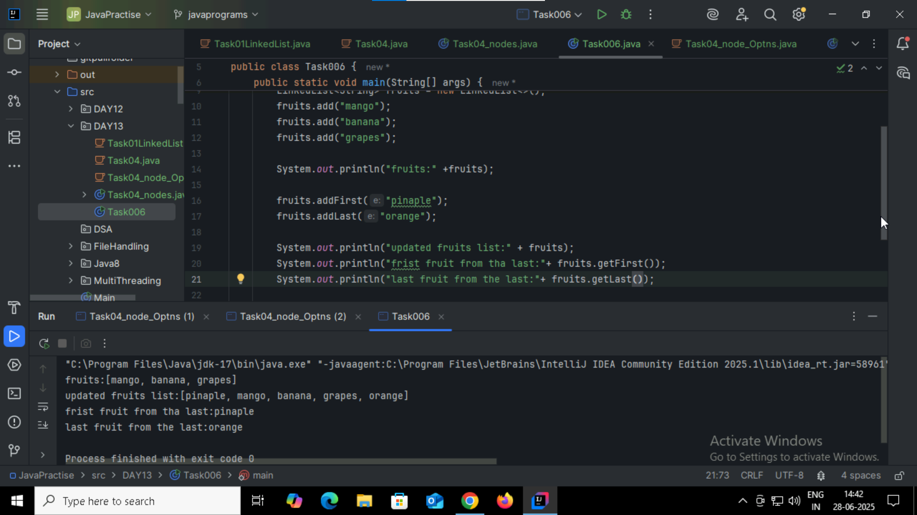

Task007:

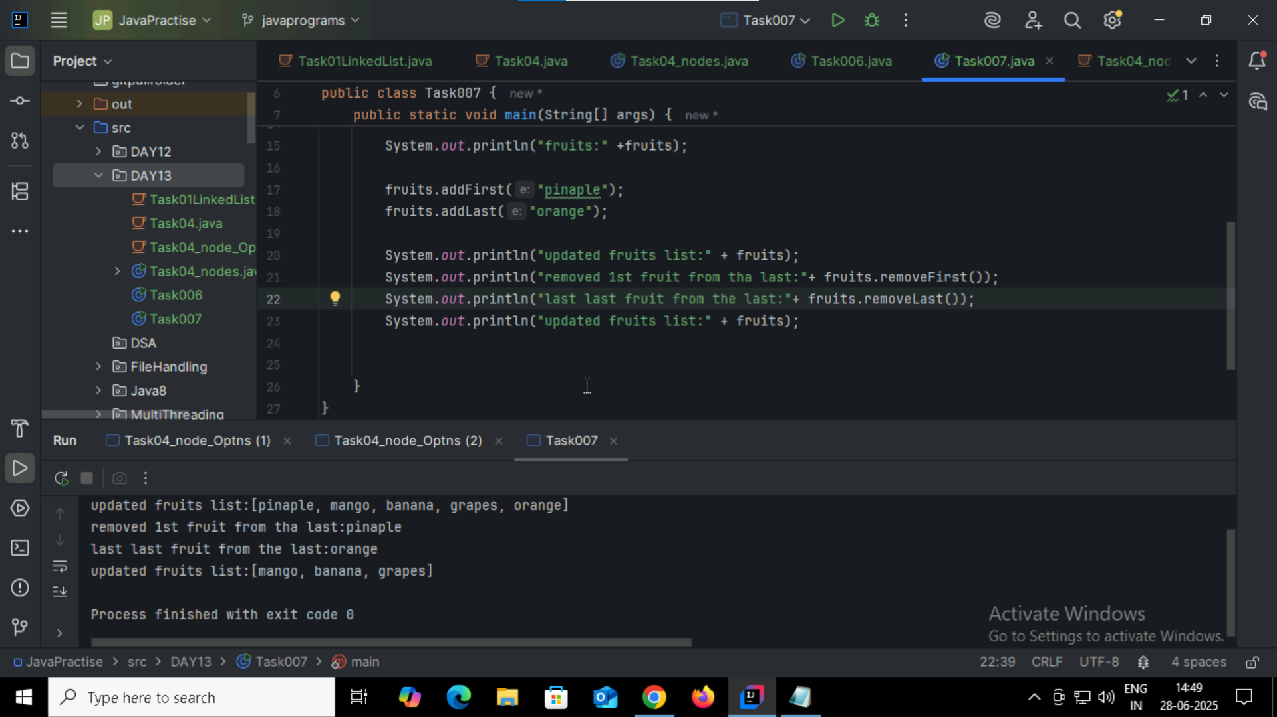

Task 8: in the list update the 1st element to a new value Hint: use set(1, "new value");  
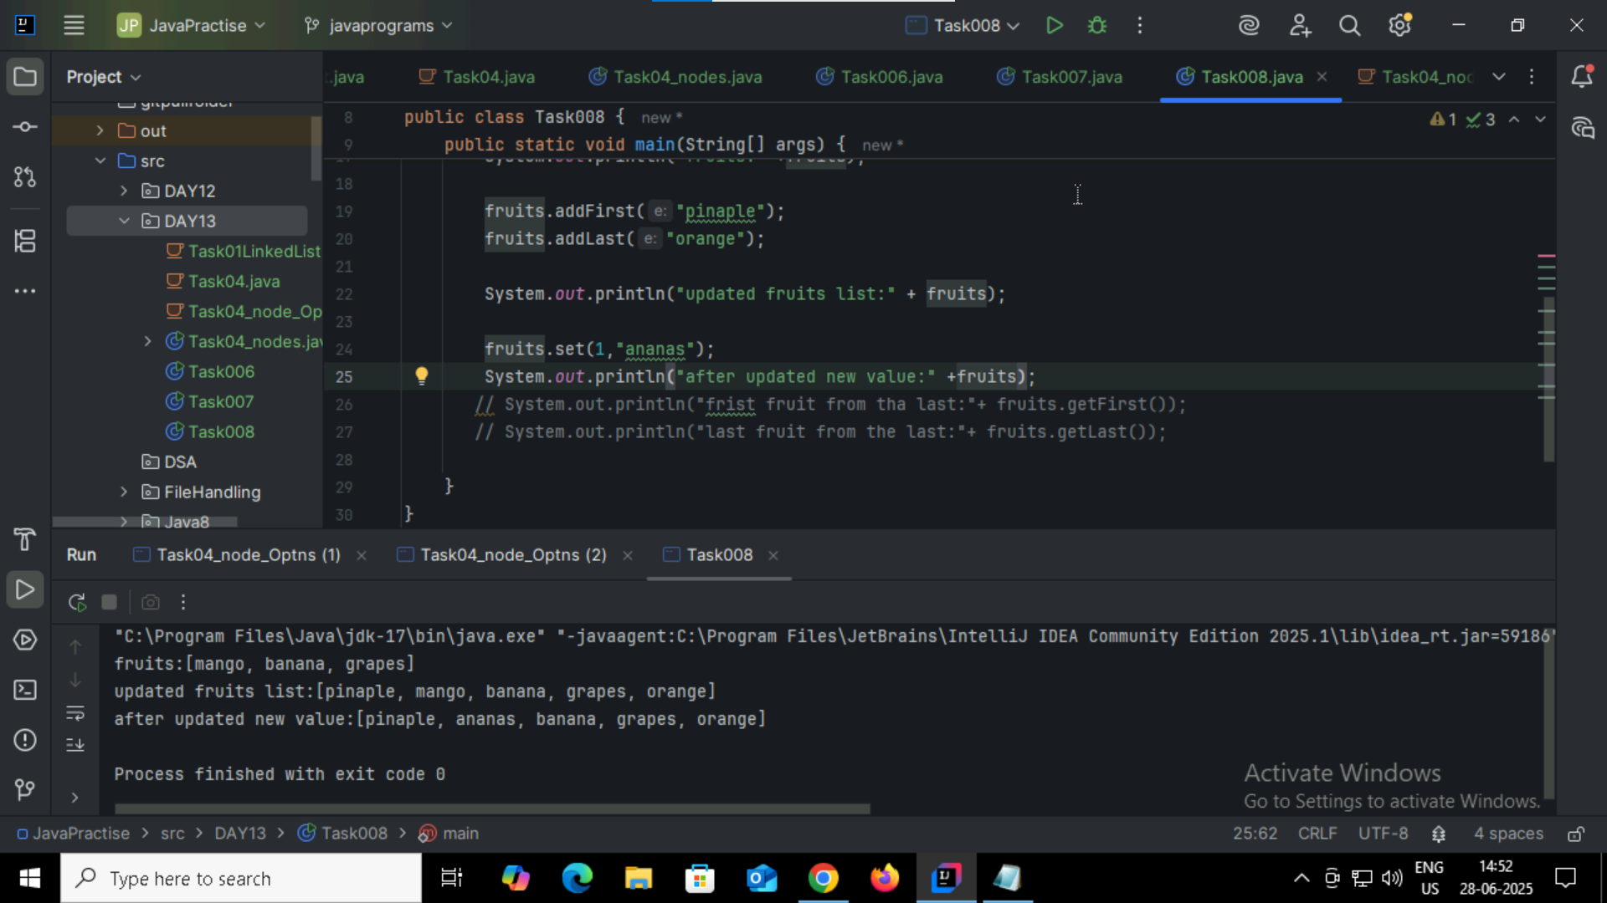

Task009:  
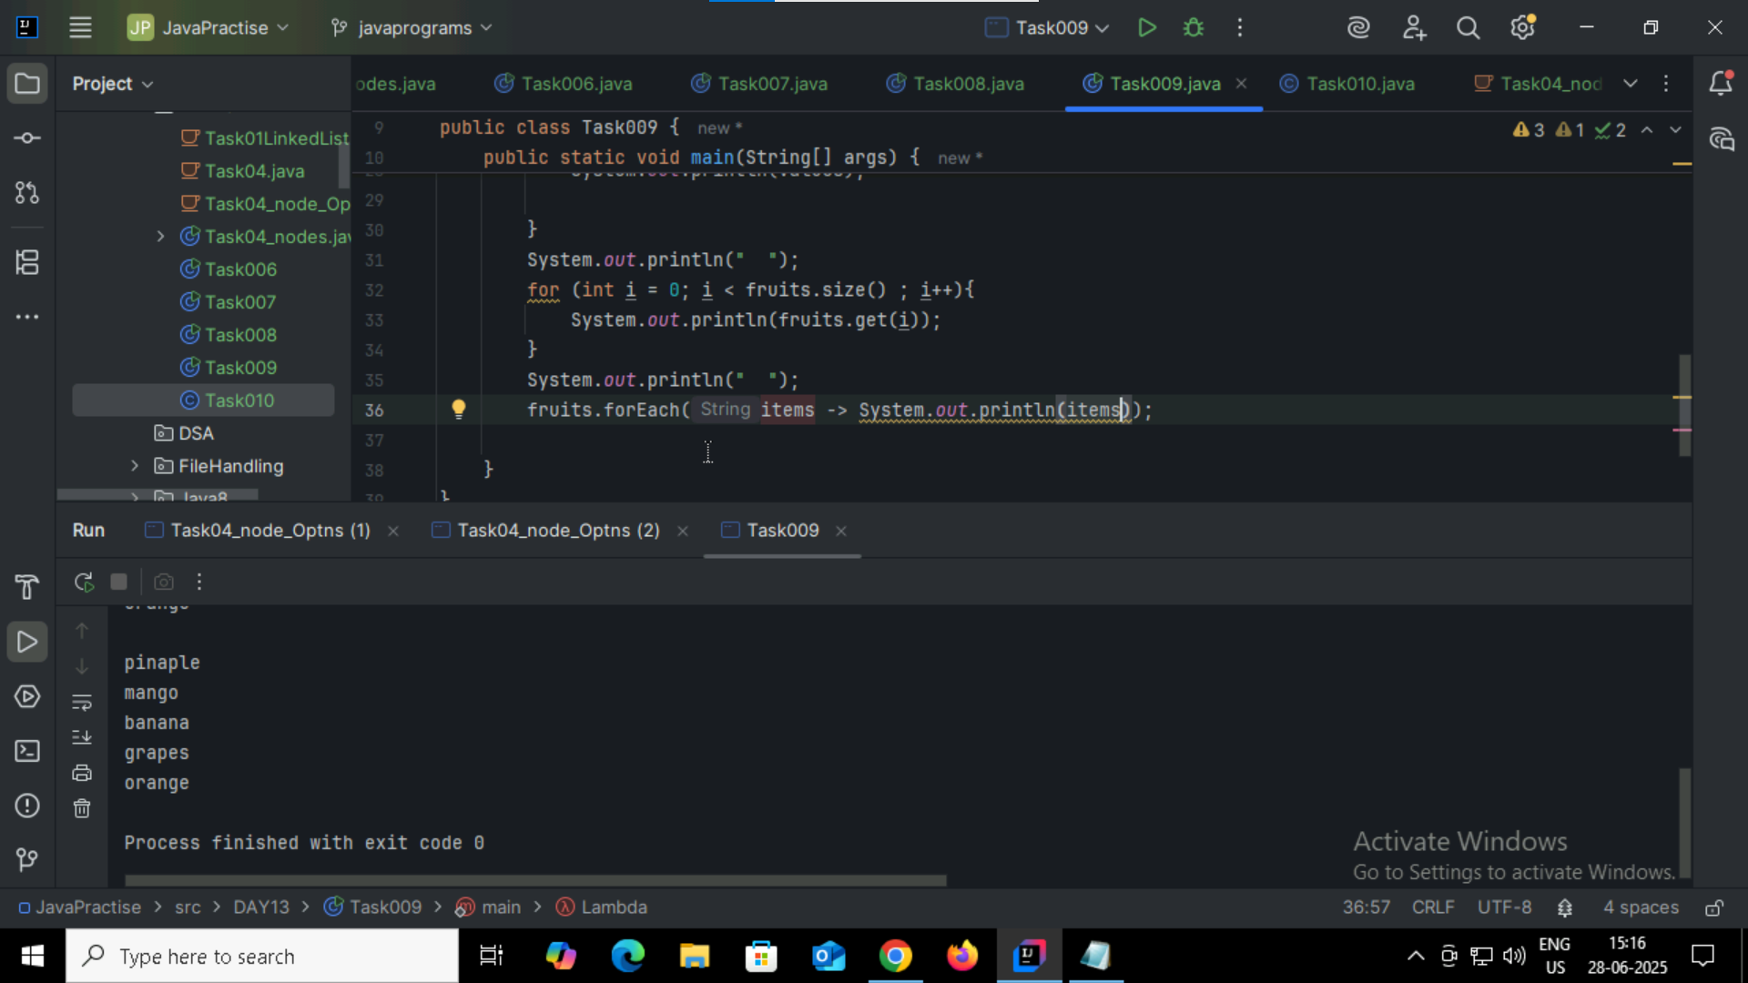

Task010:

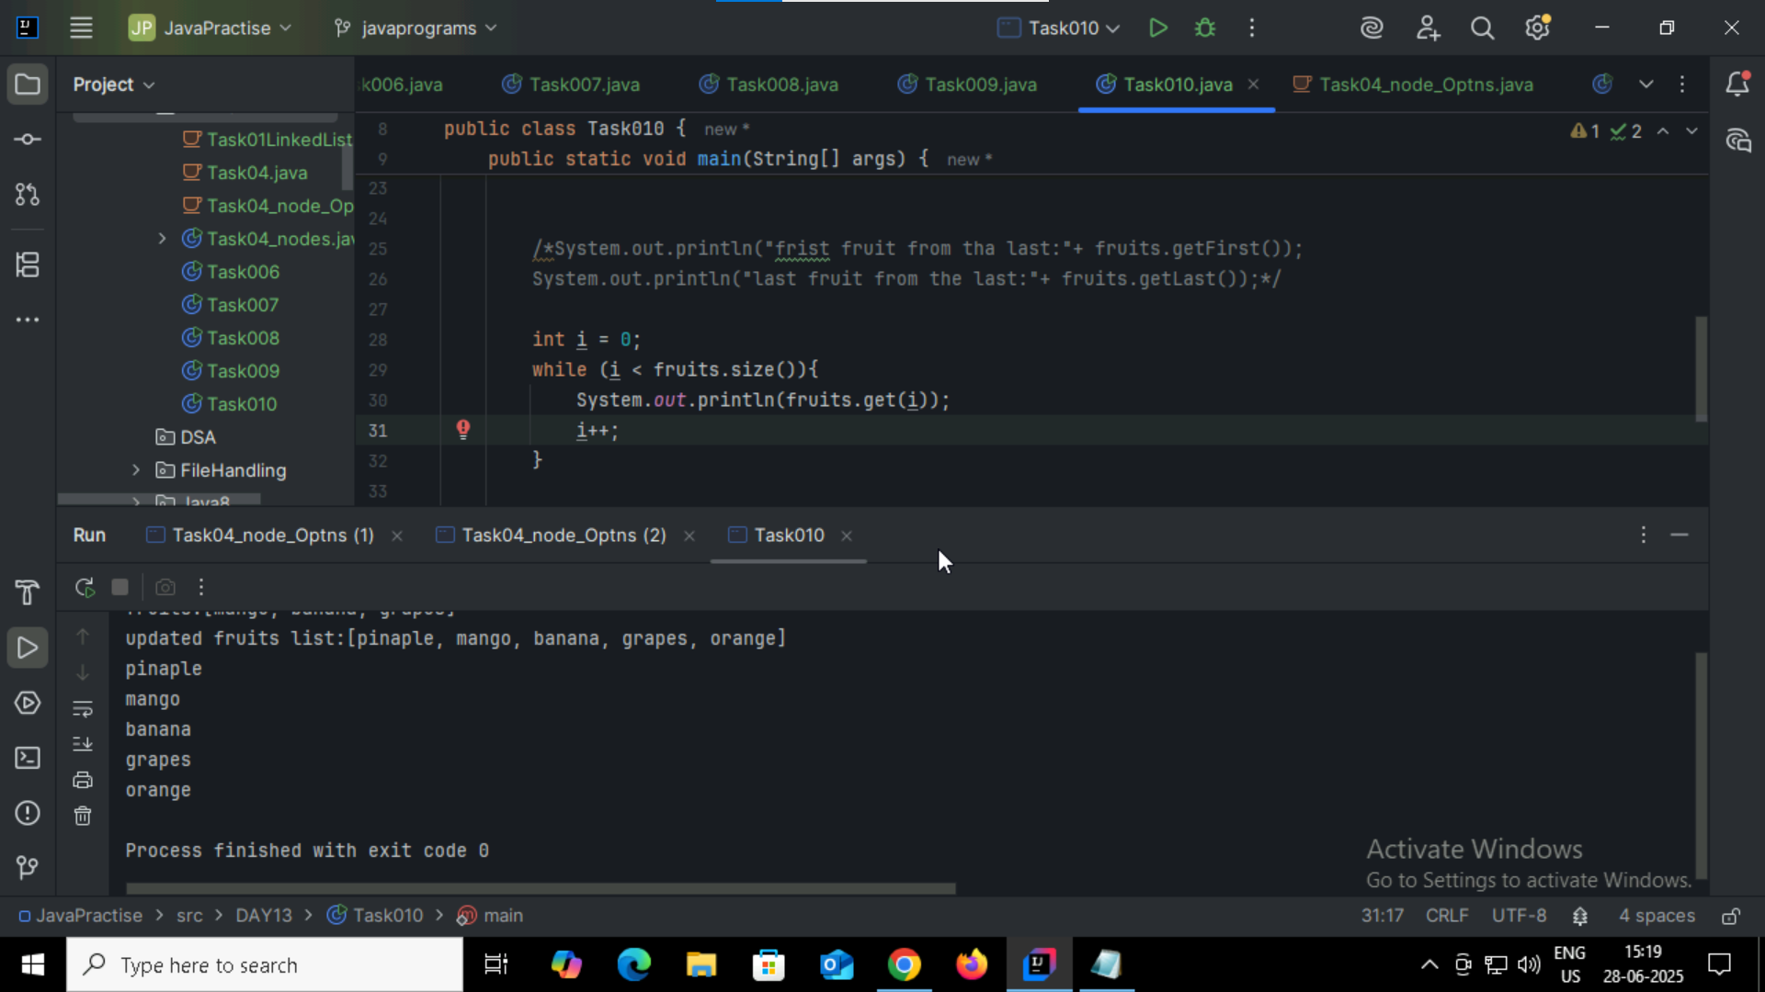

Task11: Object[] arr = list.toArray();System.out.println(Arrays.toString(arr));

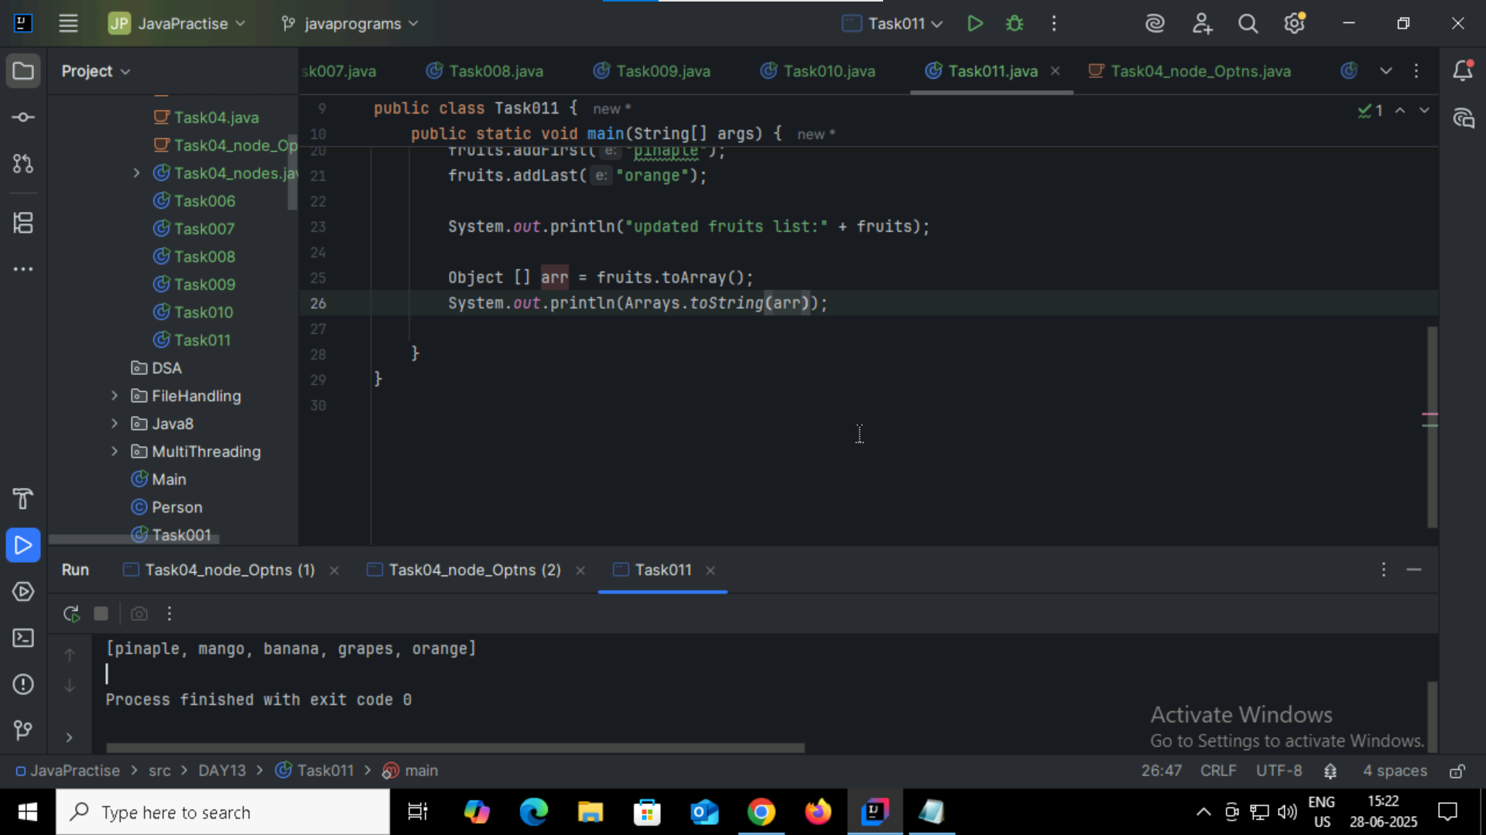

Task012: push() and pop()

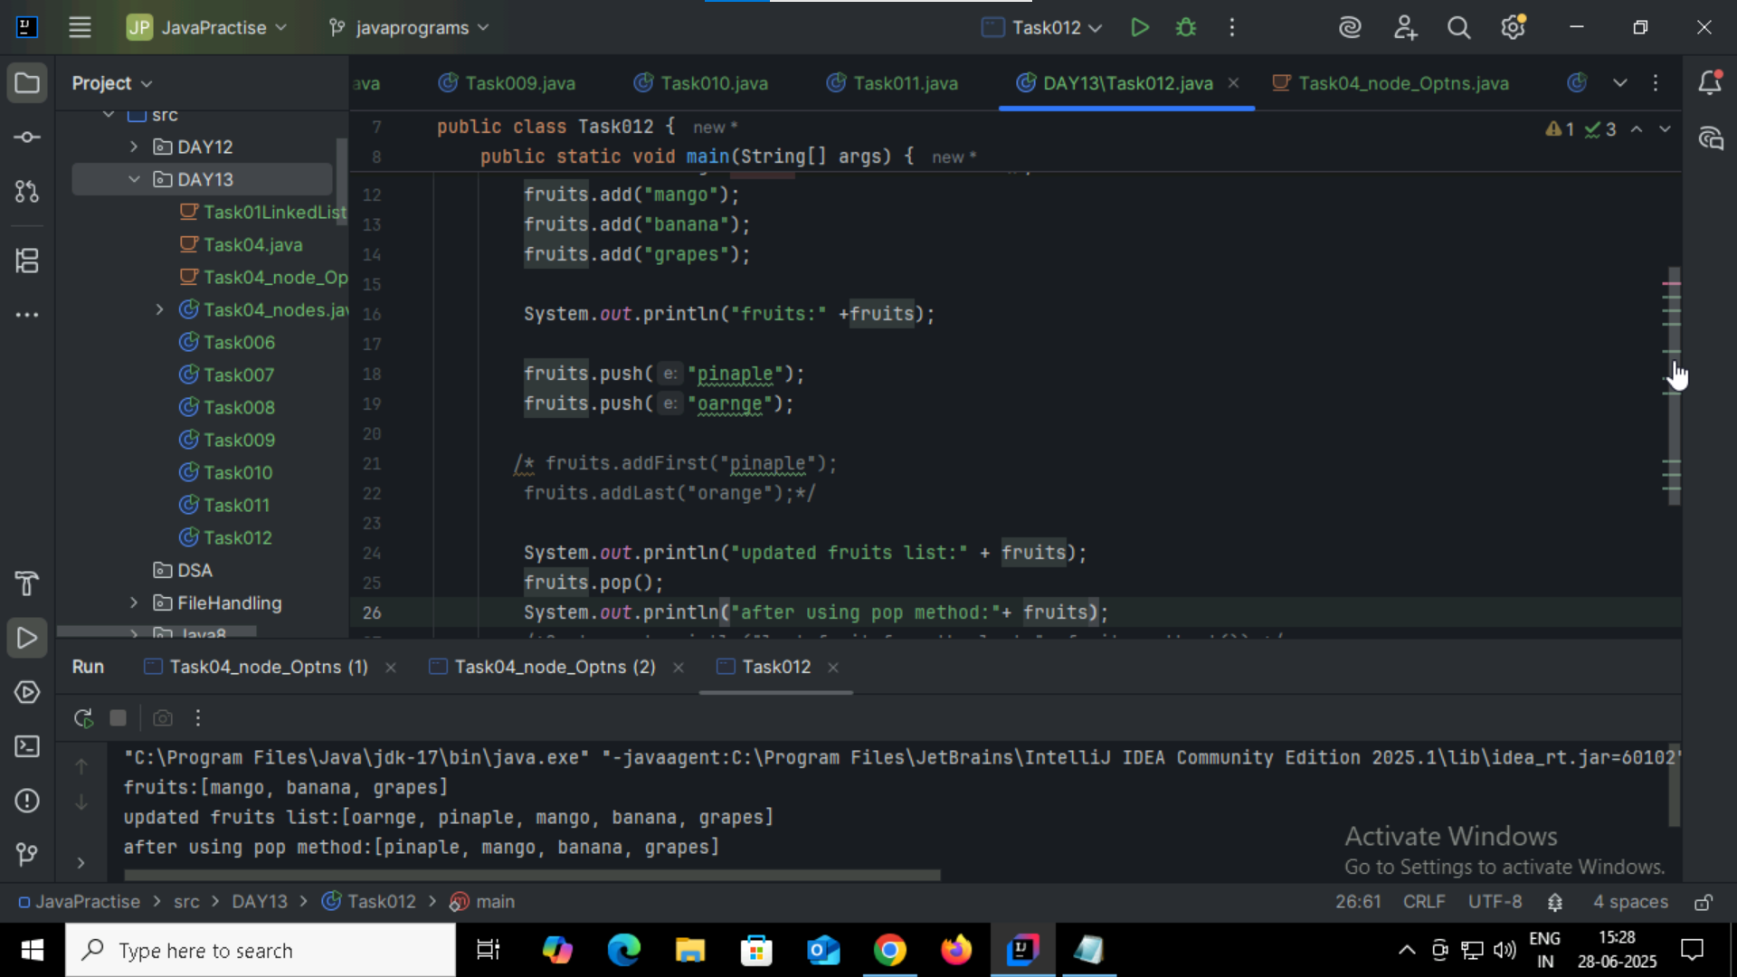

Task013: clone()  
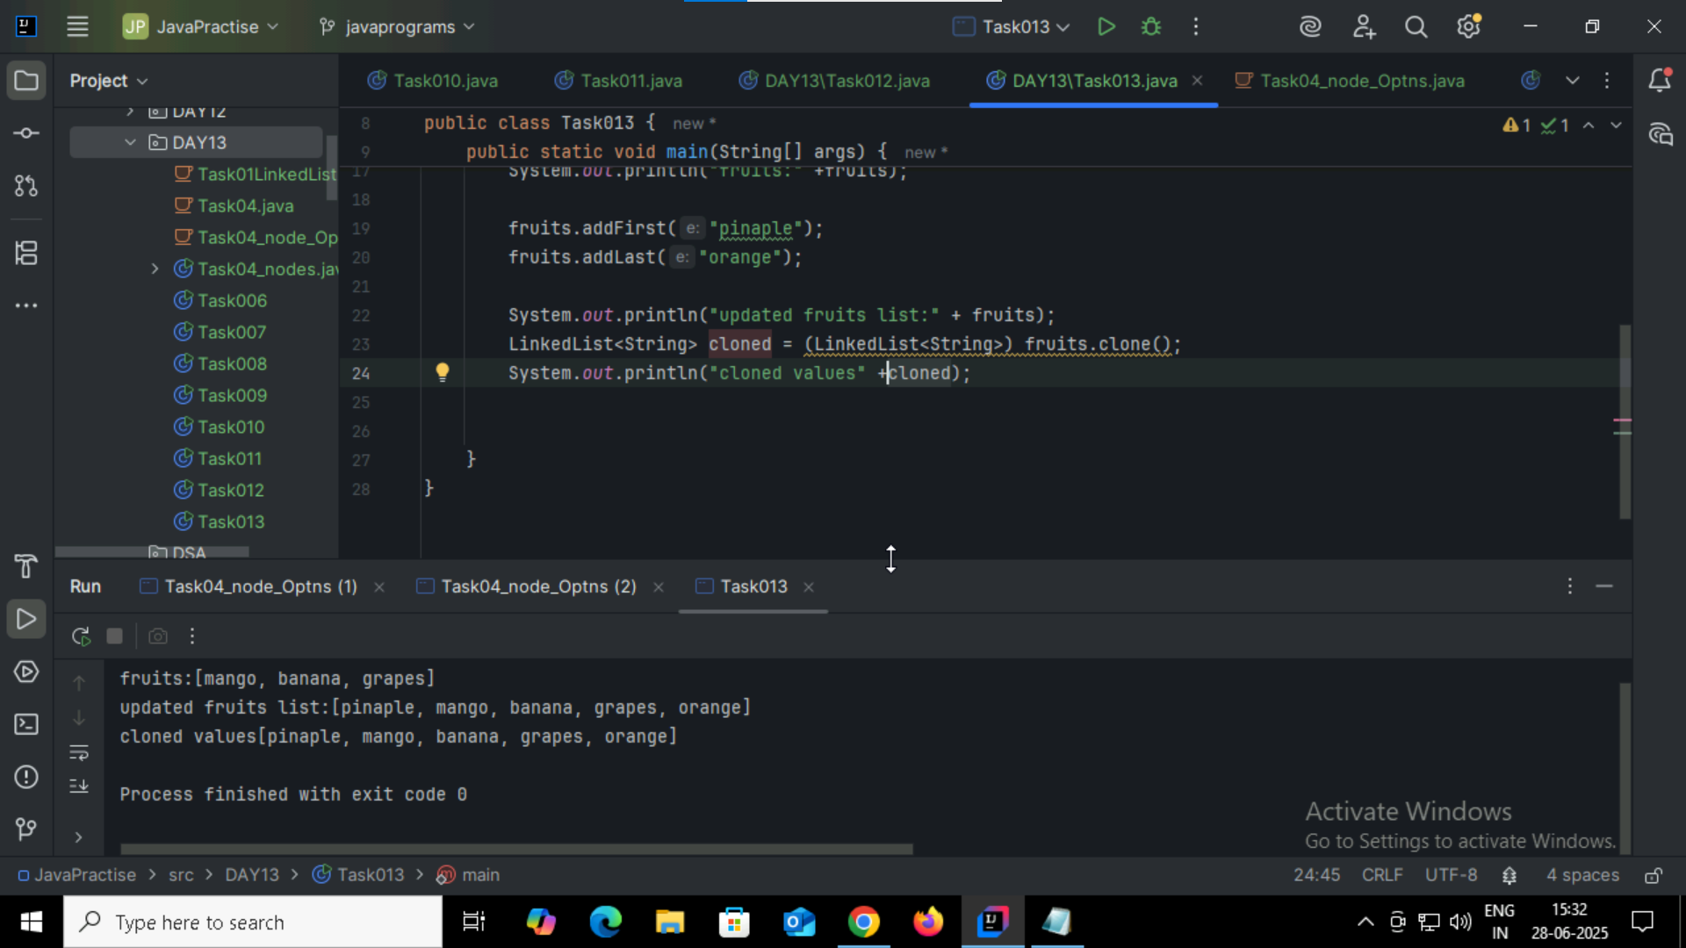

Task14:splititerator

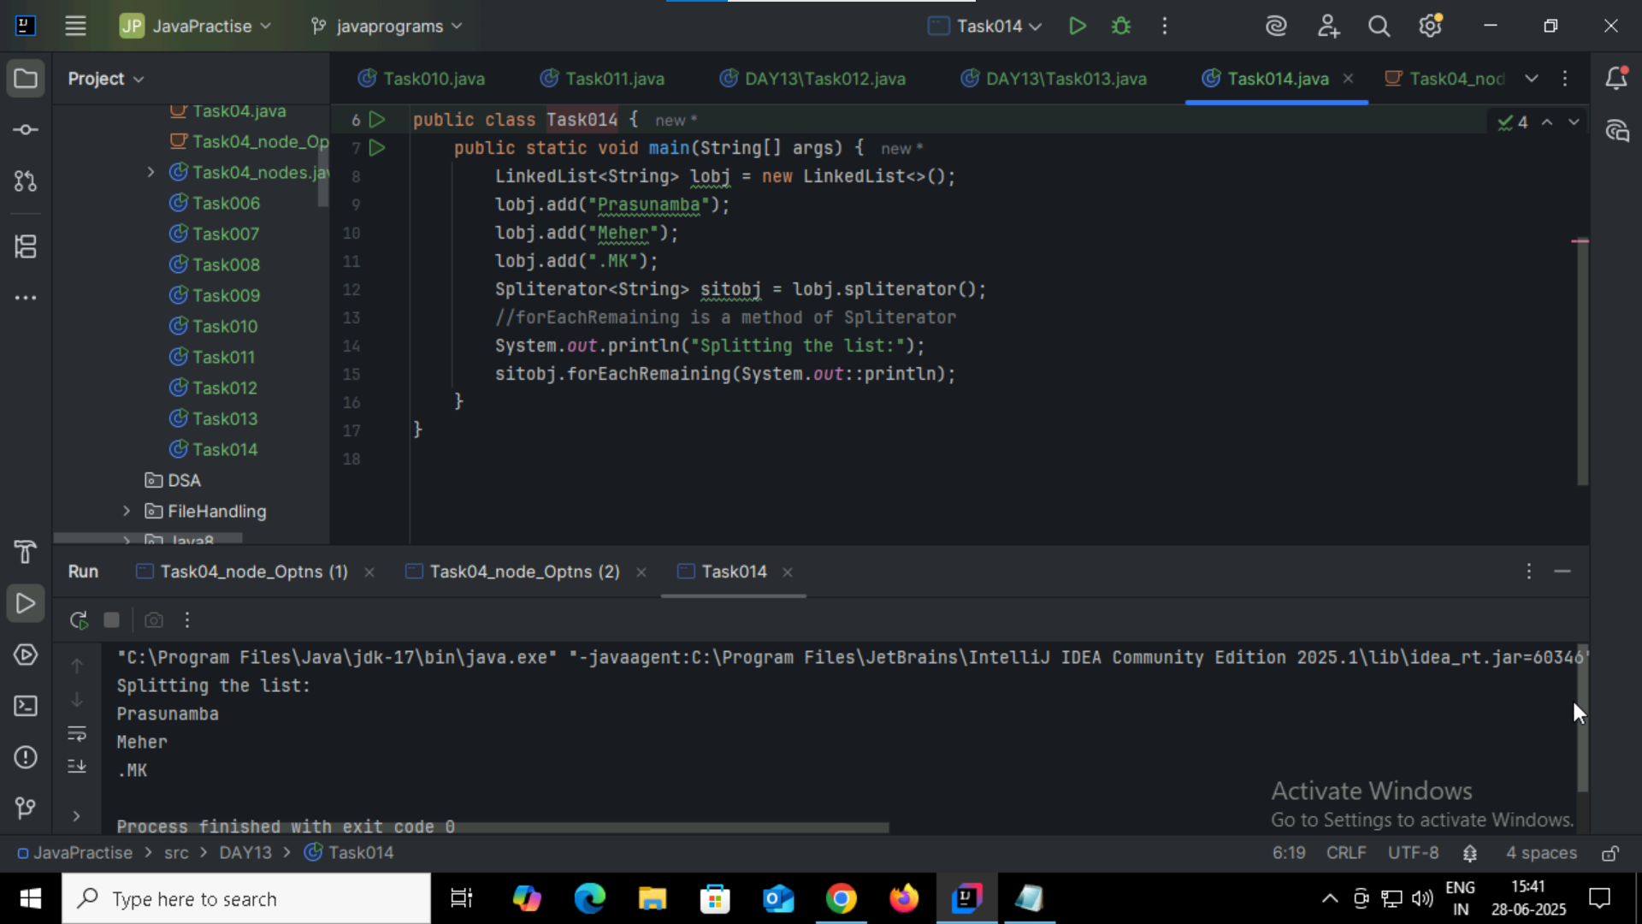

Task15: splititerator

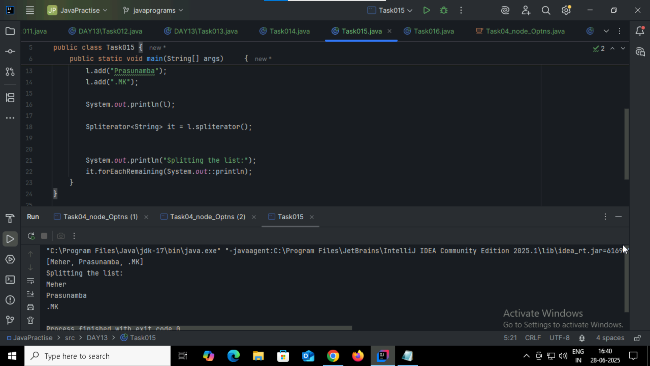

Task016: doubly LinkedList

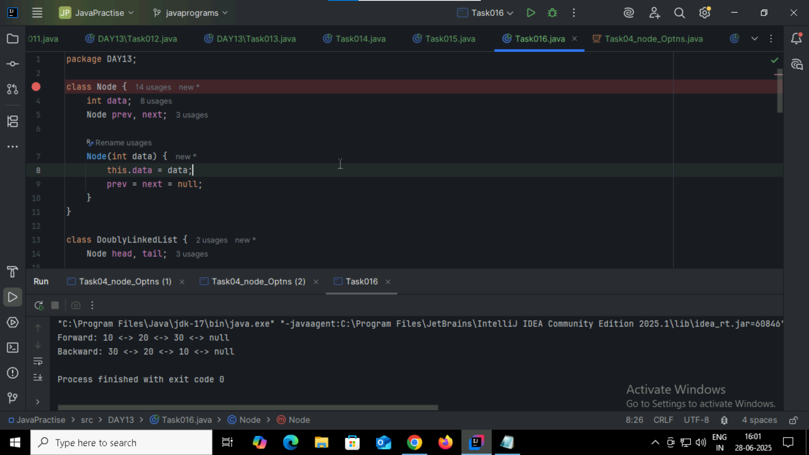

Task017:

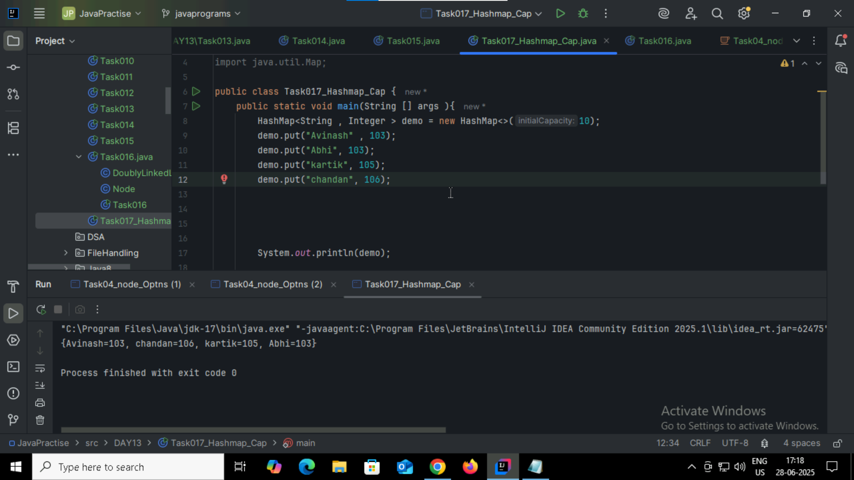

Task18:

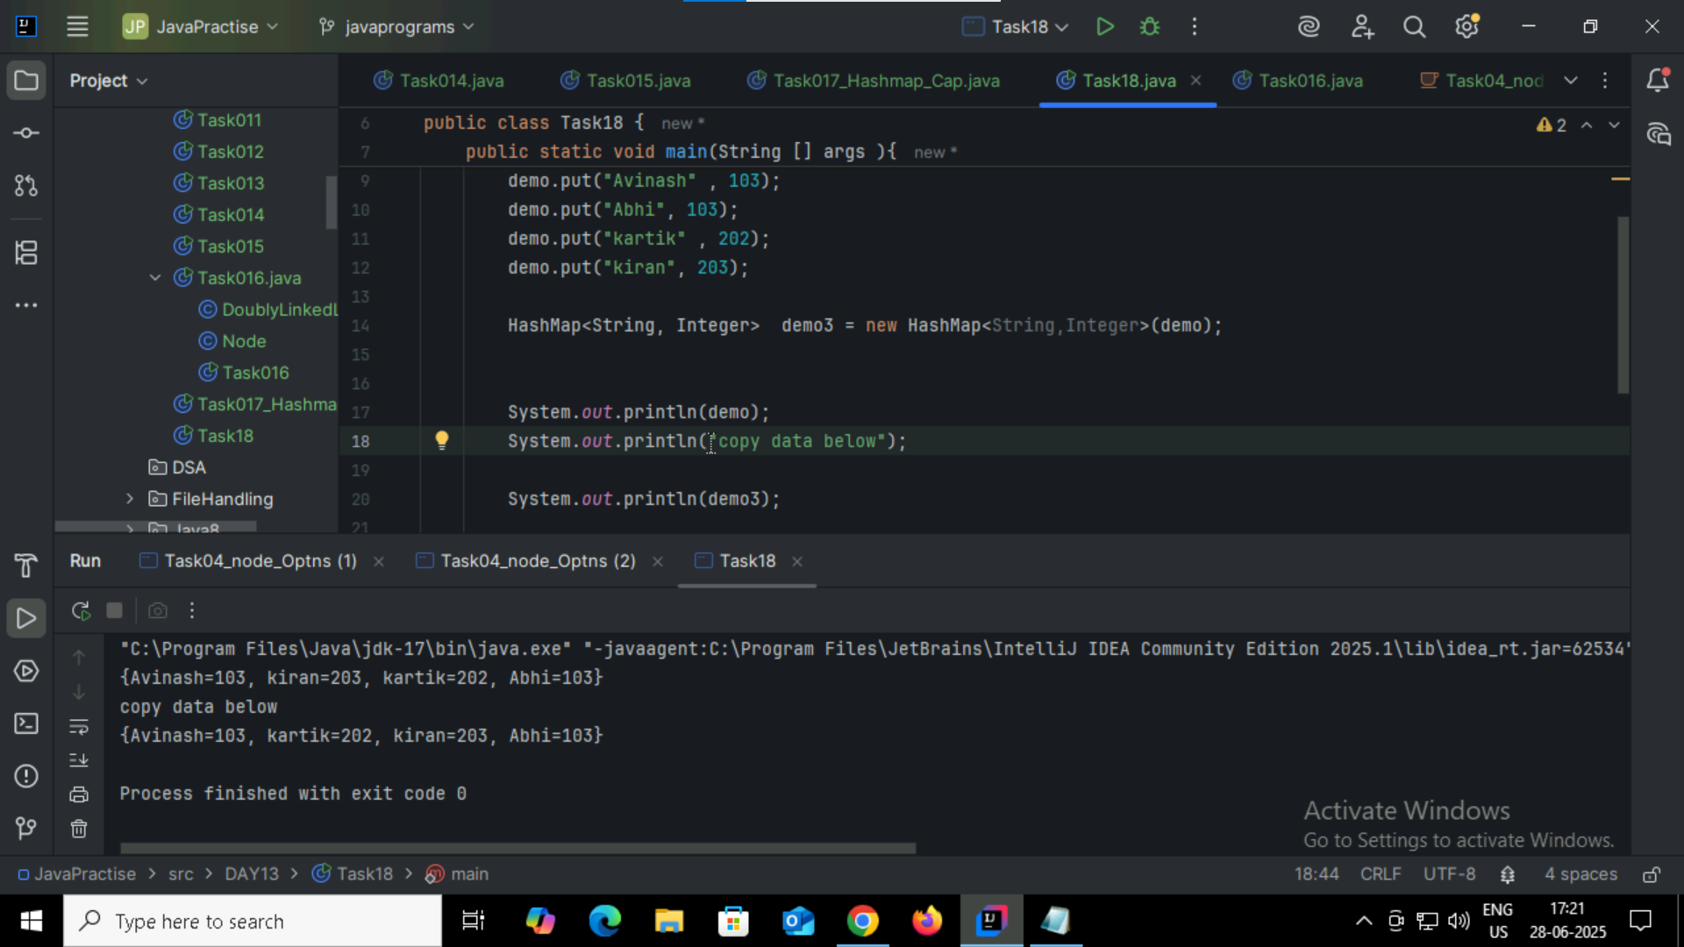

Task19:

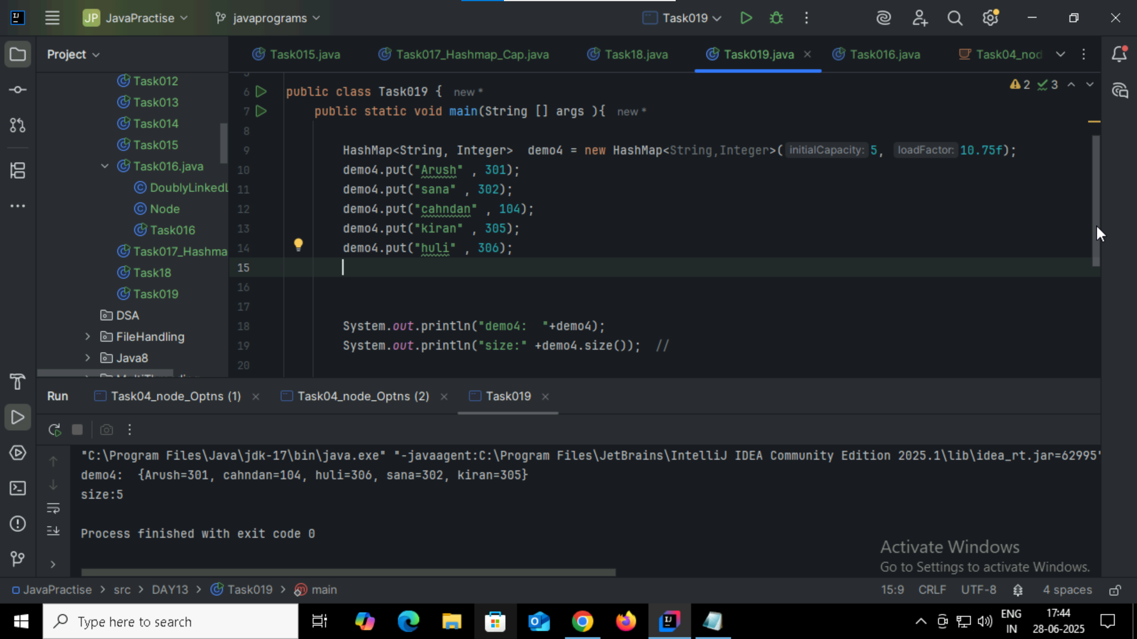

Task020_DS_HashMapCreateMethods:

Different methods to create a hashmap in java :

1) Constructing a hashmap with default capacity

ex:

 HashMap<String, Integer> hm1 = new HashMap<String, Integer>();

2) Constructing a hashmap with a capacity 10

ex:

HashMap<String, Integer> hm2 = new HashMap<String, Integer>(10);

3)copy one map to another map

ex:

HashMap<String, Integer> hm3 = new HashMap<String, Integer>( hm2);

4)

Specifying load factor along with the capacity

ex:

 HashMap<String, Integer> hm4= new HashMap<String, Integer>(10, 0.75f);

Initial capacity  ===10

Load factor  === 0.75f

Task021:

